Bonding & Structure Practical - Part ii

Aim: to use physical properties to identify the type of bonding in different substances |  | Materials required  - Substances A – F  - Watchglass  - 100 cm³ beaker  - carbon rods  - leads  - power pack  - bulb  - glass rod
What to do:

1. Add ½ spatula of solid to ½ test tube full of water. Stir with a glass rod and decide if the substance is soluble or insoluble.

2. Use the apparatus shown to find out which of the solids conduct electricity.

3. IF THE SUBSTANCE IS SOLUBLE then repeat the electrical conduction test on the AQUEOUS solution.

Set up the apparatus as shown below. Half fill the beaker with distilled water, add 1 spatula of the soluble solid and stir. Connect the circuit and note whether the lamp lights.
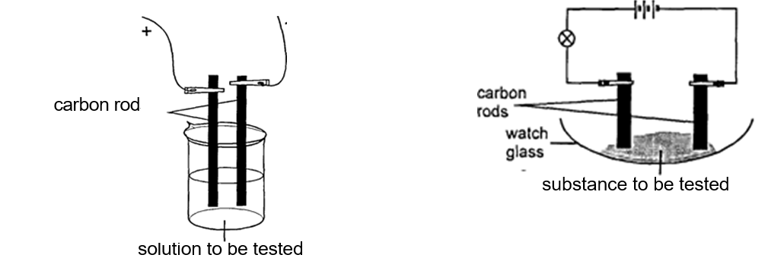

4. Wash the beaker and carbon rods with distilled water. Test
the other soluble substances in the same way.

Record your results in the table on sheet 8b(iii)

Unknown samples may be hazardous, so be careful
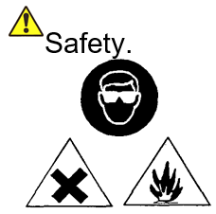

Analysis of your results:

- How could you distinguish an ionic substance from a covalent and a metallic substance?

- Look at your results in columns 5,6 & 7 and decide which of the substances you have tested is ionic, covalent and metallic. Write your answers in column 8 of Worksheet 8b(iii).

